Pet Health Manager
BUSINESS PLAN
A local-first health management app for pet owners
Project: Pet Health Manager
Team: Pet Health Manager Project Team
Members: Lu Siyu | He Yuxin | Huang Lidian
Date: October 21, 2026
TABLE OF CONTENTS
1. Executive Summary 5
1.1 Project Overview 5
1.2 Target Users and Core Pain Points 5
1.3 Core Value and Unique Selling Points 5
1.4 Market Size 5
1.5 Business Model Overview 6
1.6 Key Financial Projections 6
1.7 Funding Requirements and Use of Funds 6
2. Company Overview 7
2.1 Company Name and Legal Structure 7
2.2 Goals and Vision 7
2.3 Target Customers 7
2.4 Current Stage 7
2.5 Team and Advisors 8
3. Product Description 9
3.1 App Overview 9
3.2 Unique Selling Points 9
3.3 Target User Persona 9
3.4 Core Functional Modules 10
3.5 User Journey 11
3.6 Technical Architecture 11
3.7 IP, Patents, and R&D Plan 13
3.8 Expected Market Performance 13
4. Market Analysis 14
4.1 Industry Background 14
4.2 Market Size and Growth Forecast 14
4.3 Target Market and Audience 15
4.4 User Research Findings 16
4.5 Competitive Analysis 18
4.6 Market Positioning and Opportunity 20
4.7 Quantitative and Qualitative Support 20
5. Business Model and Revenue Strategy 22
5.1 Revenue Model 22
5.2 Subscription (Core Revenue) 22
5.3 Value-Added Services 23
5.4 Pet Insurance Referrals 23
5.5 Veterinary Clinic Partnerships 23
5.6 Pet Product Recommendations 23
5.7 Pricing Strategy 23
5.8 Path to Profitability 24
5.9 Key Partners 24
6. Marketing Strategy 25
6.1 Acquisition Channels 25
6.2 Launch Plan and Rollout 25
6.3 Marketing Budget by Stage 27
6.4 User Retention Strategy 27
6.5 Marketing Metrics 28
7. Development and Operations Plan 29
7.1 Development Plan and Milestones 29
7.2 Development Costs 29
7.3 Operations Plan 30
7.4 Lifecycle Goals 31
7.5 Team Roles and Collaboration 32
8. Financial Projections 33
8.1 Key Assumptions 33
8.2 Revenue Projections 33
8.3 Projected Income Statement 34
8.4 Break-Even Analysis 34
8.5 Cash Flow Projections 34
8.6 Three-Year Financial Summary 35
9. Team 36
9.1 Members and Responsibilities 36
9.2 Background and Capabilities 36
9.3 Advisors and Non-Technical Staff 37
9.4 Organizational Chart 37
9.5 Equity and Stakeholders 37
10. Risk Analysis and Mitigation 38
10.1 Market Competition Risk 38
10.2 Technical Implementation Risk 38
10.3 User Acquisition Risk 38
10.4 Data Privacy and Compliance Risk 38
10.5 Financial Risk 39
10.6 Risk Mitigation Summary 39
11. Appendix 40
11.1 Data Sources 40
11.2 References 40

1. Executive Summary

1.1 Project Overview
Pet Health Manager is a Chinese-language health management app for first-time urban pet owners. Built around a local-first design principle, it brings pet profiles, vaccinations, deworming, weight, medication and veterinary visits into one structured record. Smart reminders, family sharing and an AI health assistant help owners manage their pets' health day to day. The project is currently at the concept and MVP development stage and will launch first on Android.

1.2 Target Users and Core Pain Points
The target users are urban young professionals who are first-time pet owners, mostly aged 25–35 and predominantly cat owners. They face three core pain points: health information is scattered across WeChat chats, paper receipts and multiple apps, making a continuous record difficult; vaccination, deworming and follow-up dates are easily forgotten; and at the clinic they cannot clearly recall the pet's medical history, which slows communication.

1.3 Core Value and Unique Selling Points
The product offers three differentiated values. First, local-first storage: sensitive health data stays on the user's device by default and is not uploaded. Second, family sharing: household members can maintain the same pet's records and receive synchronized reminders. Third, personalized reminders based on species, age and history, plus an AI health assistant in the subscription tier for preliminary symptom analysis and report summaries.

1.4 Market Size
According to the 2026 China Pet Industry White Paper (Consumer Report), China's urban dog and cat consumer market reached RMB 312.6 billion in 2025, up 4.1% year on year, and is projected to reach RMB 405.0 billion by 2028. Pet medical spending was about RMB 86.3 billion, or 27.6% of the total, the second-largest category after pet food.

1.5 Business Model Overview
The project uses a freemium model with subscription as the core revenue stream, supplemented by insurance referrals and veterinary clinic partnerships. The free tier includes pet profiles, basic records and one pet. The premium tier costs RMB 12–18 per month or RMB 68–98 per year and adds multi-pet management, data export, AI health reports and family sharing.

1.6 Key Financial Projections
On a conservative basis, Year 1 assumes average MAU of 1,000, 50 paying users, revenue of RMB 9,000 and net profit of RMB 4,500. Year 2 assumes MAU of 2,500, 200 paying users, revenue of RMB 34,800 and net profit of RMB 24,200. Year 3 assumes MAU of 4,500, 450 paying users, revenue of RMB 76,800 and net profit of RMB 57,700. The marketing budget is RMB 1,000–3,000 per year. Monthly break-even is expected around Month 7.

1.7 Funding Requirements and Use of Funds
No external funding is planned. The team will self-fund about RMB 10,000, mainly for domain and cloud services, AI API calls, test devices, design assets and early promotion. During the MVP stage, free tiers from Firebase, Gemini and similar services will be used to keep fixed costs low.

2. Company Overview

2.1 Company Name and Legal Structure
The company name is provisionally “Pet Health Manager Project Team”, a virtual operating entity for the course project. If commercialized, it will be registered as a limited liability company; registered capital, equity structure and business scope will be determined before registration. At this stage there is no actual business registration, external financing or equity transaction; all income and expenses are tracked in the team's internal ledger.

2.2 Goals and Vision
The goal is to become the most trusted local-first health management tool for first-time pet owners in China, freeing pet health information from scattered, fragile chats and paper receipts and turning it into a complete, portable record controlled by the owner.
The three-year milestones are: complete the MVP launch and reach 1,000 MAU in Year 1; improve family sharing and data export and reach 2,500 MAU in Year 2; reach 4,500 MAU, lift paid conversion to 10% and establish a second revenue curve from insurance referrals and clinic partnerships in Year 3.

2.3 Target Customers
The core customers are first-time urban cat or dog owners, especially white-collar professionals aged 25–35 with a bachelor's degree or above who are comfortable using mobile apps in daily life. Secondary customers include multi-pet households, family members who coordinate care remotely, and light service providers such as boarding and home-feeding services.

2.4 Current Stage
The project is at the concept stage. Market research, needs analysis, competitive analysis and preliminary financial modeling are complete, and the MVP is in development. The MVP prioritizes three modules: pet profiles, health records and smart reminders. Family sharing, data export and the AI health assistant will be released in stages after MVP validation to control development risk.

2.5 Team and Advisors
The project has three members. Lu Siyu leads product and technology and serves as team leader; He Yuxin leads marketing and user research; Huang Lidian leads business and finance. They cover product development, marketing operations and financial modeling respectively. There are currently no external advisors; all required functions are handled directly by the team.

3. Product Description

3.1 App Overview
Pet Health Manager is an Android-first, lightweight health management tool centered on a continuous, structured health record for one or more pets. The app works offline: users can create a local profile on first launch without registering an account, and can sign in later when they want family sharing or cloud backup.

3.2 Unique Selling Points

3.2.1 Local-First Data Privacy
Pet health data is stored by default in a local Room database on the device and is not uploaded to the cloud; users can choose whether to enable encrypted backup. The app integrates no advertising SDK and does not request contacts, location or other unnecessary permissions. Users can export their full record or permanently delete data at any time. Compared with cloud-account platforms, local-first reduces the risks of data leakage and platform lock-in.

3.2.2 Family Sharing
One pet can be managed by multiple household members. The owner can invite family members, assign “can edit” or “view only” permissions, share vaccination, deworming, medication and visit records, and let all members receive reminders. This addresses information gaps when traveling, living apart or sharing care, and is a core benefit of the subscription.

3.2.3 AI Health Assistant
The subscription tier includes an AI health assistant that uses species, age, prior records and the user's description to generate a preliminary symptom assessment, a pre-visit question list and a health report summary. All AI output is labeled “for reference only; not a substitute for veterinary diagnosis”. Users must authorize each request, and content is de-identified before sending. The goal is to reduce the cost of organizing information and communicating with veterinarians, not to replace professional care.

3.3 Target User Persona
Lin Xiao is 27 and works as an operations specialist at an internet company in Guangzhou. She lives alone with Doudou, a one-year-old British Shorthair. As a first-time cat owner, she learns about pet care from Xiaohongshu, WeChat groups and veterinary clinic accounts. She uses a flagship Android phone and manages daily life with a notes app and calendar.
Her pain points are concrete: the vaccination booklet sits in a drawer, and deworming dates depend on memory and notes; when she travels, her roommate does not know the feeding or vaccination schedule; at the clinic, when the vet asks about the last deworming, weight changes and medication, she can only scroll through chat history. She will pay for peace of mind, reliability and privacy, but is sensitive to forced registration, frequent notifications and advertising.

3.4 Core Functional Modules

3.4.1 Pet Profiles
Store basic information including nickname, species, breed, sex, birth or adoption date, neuter status, microchip number, weight, coat color and photos. Profiles support multiple pets; the premium tier has no pet limit, while the free tier supports one pet.

3.4.2 Health Records
Record weight, vaccinations, deworming, medication, allergies, visits, lab reports and notes on a timeline, with photo upload for paper documents. The app provides templates for common vaccines and deworming schedules and allows custom items. All records are ordered chronologically to form a traceable health timeline.

3.4.3 Smart Reminders
Generate vaccine, deworming, follow-up and medication reminders from species, age, breed and the previous record. Reminders are triggered locally through WorkManager and do not depend on the network. Users can snooze, skip or mark them complete. When family sharing is enabled, all household members receive the same reminders.

3.4.4 AI Health Assistant
For subscribers, the assistant provides three capabilities: preliminary symptom analysis with possible directions and observation advice; report summaries that turn lab results and visit notes into readable digests; and a pre-visit question list to help owners communicate efficiently with the vet. This module is not part of the MVP and will enter a limited beta after the first three modules are stable.

3.4.5 Family Sharing
Invite family members or caregivers and assign owner, editor or viewer roles. Members can jointly maintain records, receive reminders and export the profile. Shared data uses an optional end-to-end encrypted sync scheme; the owner can revoke access at any time and review an activity log.

3.4.6 Data Insights
Visual summaries such as weight trends, vaccine completion, deworming cycles, visit frequency and a health score help owners spot unusual changes. Users can export records as PDF or CSV for visits, boarding or a move, and hand them to a vet or a new caregiver.

3.5 User Journey
The typical path is as follows:
1. Download the app and choose local use or create an account; local mode allows first-time profile creation without a phone number.
2. Add a pet and enter species, age, weight and previous vaccination and deworming information.
3. The app generates vaccine, deworming and follow-up reminders based on species and age; the user confirms or adjusts the dates.
4. Record weight, medication, visits and unusual symptoms in daily use, with photo upload for documents.
5. Receive a reminder before the due date and mark it complete with one tap; family members receive the same notification.
6. Export the health record or generate a summary before a visit and show it directly to the veterinarian.

3.6 Technical Architecture
The Android client is built with Kotlin and Jetpack Compose and is organized into four parts: the presentation layer, the domain and data layer, the background task layer and external services. The presentation layer uses a single Activity with Compose navigation and follows Material 3, with emphasis on large fonts, dark mode and one-handed use.
The domain and data layer follows MVVM and uses Hilt for dependency injection. A Room database is the single source of truth for local data, and repositories encapsulate read and write logic; DataStore holds user preferences and privacy settings. This layer does not depend on the network, so profiles, records and reminders work offline.
The background task layer uses WorkManager to schedule vaccine, deworming, medication and follow-up reminders, and to handle optional encrypted backup and family-sharing sync. Reminders fire locally even when the app is closed; sync jobs retry with exponential backoff and never block local use.
For external services, the AI assistant calls the Gemini API for symptom analysis and report summaries; every request requires explicit user authorization and is de-identified. Family sharing and optional backup use Firebase authentication and cloud database services, with TLS in transit and client-side encryption of sensitive fields before upload. The app integrates no advertising SDK and does not collect personal information unrelated to health management.
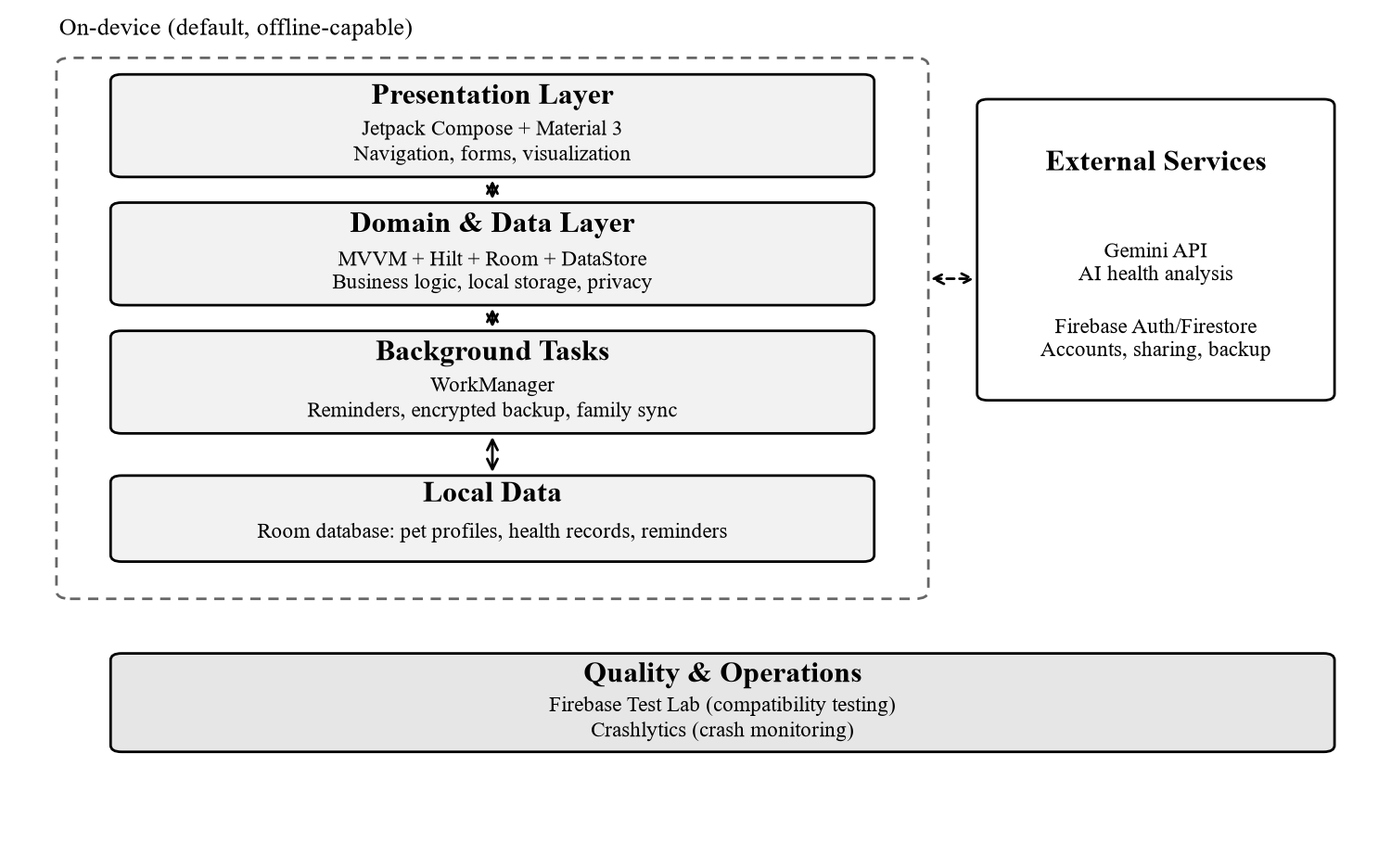
Figure 3-1 Technical Architecture and Local-First Boundary
Note: The dashed area runs locally and remains available offline. External services are used only with user authorization or when actively enabled; core features are unaffected when they are off.
Table 3-1 Technology Stack and Responsibilities
Layer | Main technologies | Responsibilities
Presentation | Kotlin, Jetpack Compose, Material 3 | UI rendering, navigation, forms and visualization
Domain & data | MVVM, Hilt, Room, DataStore | Business logic, local storage, dependency injection
Background tasks | WorkManager | Local reminders, encrypted backup, family sync
External services | Gemini API, Firebase Auth/Firestore | AI analysis, accounts, family sharing and optional backup
Quality & operations | Firebase Test Lab, Crashlytics | Compatibility testing, crash monitoring and release iteration

3.7 IP, Patents, and R&D Plan
The project does not currently seek patent protection. The client uses open-source technologies including Kotlin, Jetpack Compose, Room, Hilt and WorkManager under their respective licenses, including Apache 2.0. AI capabilities are accessed through the Gemini API under the provider's terms of service and data policy. The product name, icon and interface design will undergo trademark and copyright searches before public release.
R&D is planned in three stages. Stage 1: a three-month MVP covering pet profiles, health records and smart reminders. Stage 2: two months of beta testing, bug fixes and data export. Stage 3: three months to launch subscriptions, family sharing and a limited beta of the AI health assistant. Each stage has explicit acceptance criteria to prevent scope creep.

3.8 Expected Market Performance
Year 1 targets 3,000–5,000 downloads, about 1,700 MAU at year-end (average about 1,000), a 5% paid conversion rate and an app-store rating of at least 4.5. Acquisition focuses on campuses, pet communities and clinic partnerships rather than short-term volume. ASO will target long-tail keywords such as “pet health”, “vaccine reminder”, “deworming record” and “pet profile”, highlighting local privacy and family sharing.

4. Market Analysis

4.1 Industry Background
Chinese pet spending is shifting from “keeping pets alive” to “keeping them healthy”. According to the 2026 China Pet Industry White Paper (Consumer Report), the urban dog market reached RMB 160.6 billion in 2025, up 3.2% year on year, while the cat market reached RMB 152.0 billion, up 5.2%; cats are growing faster. Pet medical spending was about RMB 86.3 billion, or 27.6% of total spending, second only to pet food at 53.7%.
By demographic, people born in the 1990s account for 42.7% of pet owners and those born in the 2000s for 26.3%, so younger groups are now the mainstream; about 75% have a bachelor's degree or above. They are more open to science-based pet care, digital tools and privacy protection, and more willing to pay for time savings and certainty. As of December 2025, China had 1.121 billion mobile internet users, or 99.6% of all internet users (CNNIC). This provides a broad mobile foundation, although the ratio describes internet users rather than smartphone penetration among pet-owning households.
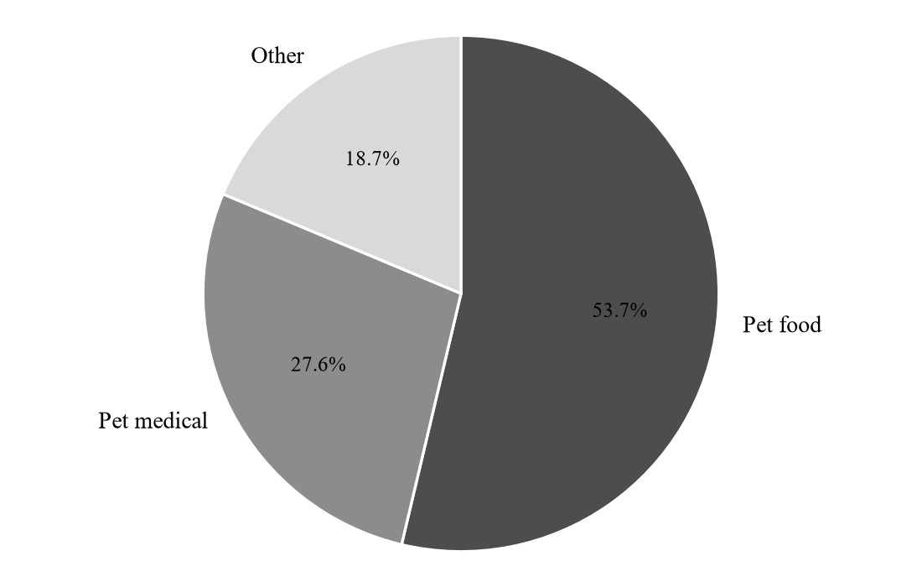
Figure 4-1 China Pet Consumption Structure, 2025
Source: 2026 China Pet Industry White Paper (Consumer Report). “Other” is the remainder after food and medical spending, including supplies, services and grooming.

4.2 Market Size and Growth Forecast
In 2025, China had about 126 million urban dogs and cats, including 72.89 million cats and 53.43 million dogs. Household penetration was about 23%, leaving room to grow compared with mature markets. From 2020 to 2025, the urban dog and cat consumer market grew from RMB 206.5 billion to RMB 312.6 billion, a CAGR of about 8.6%. The white paper projects RMB 405.0 billion by 2028, a 2025–2028 CAGR of about 9.0%.
Table 4-1 China Urban Dog and Cat Consumer Market (2020–2028E)
Year | Market size (RMB 100 million) | YoY growth
2020 | 2,065 | —
2021 | 2,490 | 20.6%
2022 | 2,706 | 8.7%
2023 | 2,793 | 3.2%
2024 | 3,002 | 7.5%
2025 | 3,126 | 4.1%
2028E | 4,050 | CAGR ~9.0% (2025–2028)

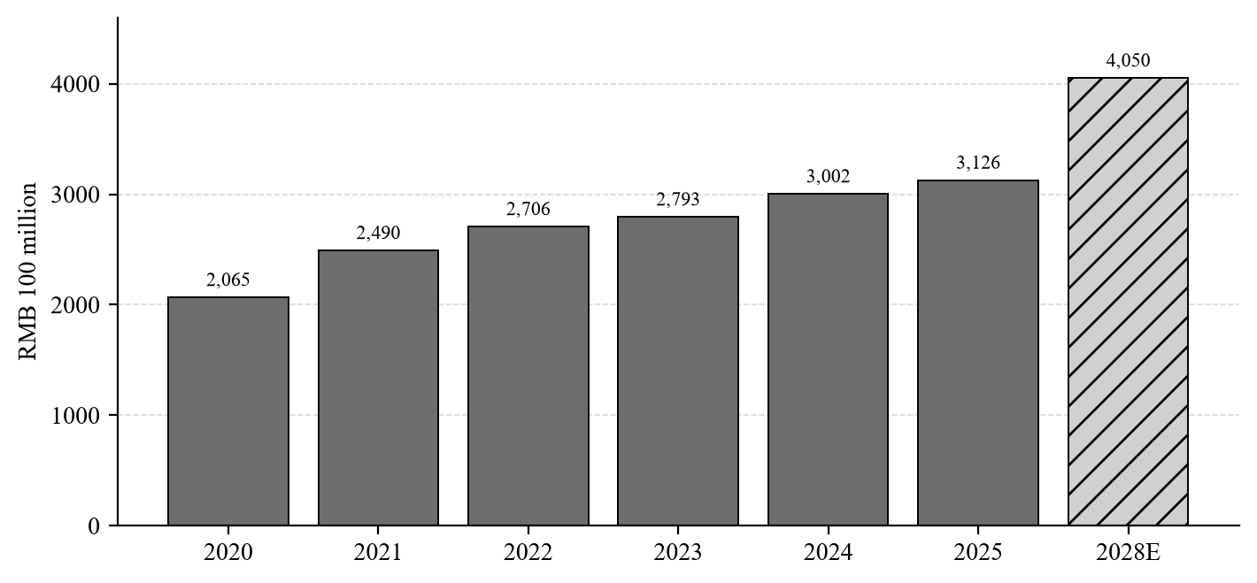
Figure 4-2 China Urban Dog and Cat Consumer Market and Forecast (2020–2028E)
Source: 2026 China Pet Industry White Paper (Consumer Report); 2028 is a forecast.

4.3 Target Market and Audience
The project uses TAM, SAM and SOM to define the target market. They describe, respectively, the total market, the serviceable segment of households and the users the team can realistically acquire in the near term. Because the units differ, the plan reports market value, potential households and user scale separately rather than adding or comparing them directly.
Table 4-2 TAM, SAM and SOM
Tier | Definition | Size
TAM | 2025 urban dog and cat consumer market in China; medical spending is a relevant reference but not the app's addressable revenue | RMB 312.6 billion; medical about RMB 86.3 billion
SAM | Urban cat-owning households, estimated from 72.89 million cats at 1.3–1.8 cats per household | Approx. 40.5–56.1 million households (range estimate)
SOM | Year 1 MAU 1,000; Year 3 MAU 4,500 and 450 paying users | Year 3 ARR RMB 76,800

SAM is not multiplied by mobile-internet penetration or the share of young users: urban mobile adoption is already near saturation, and age share does not equal target-user share; stacking them would overstate the serviceable market. The number of cats per household is a team assumption, so the SAM range needs calibration through further research. SOM is consistent with the financial forecast in Chapter 8 and assumes a conservative acquisition rate through campuses, communities and clinic partnerships.

4.4 User Research Findings
Given the time and sample constraints of a course project, the team did not run a national survey. The findings below draw on public industry reports, university surveys and app-store reviews, supplemented by the team's observations of pet owners around them. The sample is limited; the conclusions indicate the direction of demand rather than statistical inference.
First, health records are highly fragmented. Common practices include WeChat favorites and chats, phone notes, paper vaccination booklets, clinic mini-programs and multiple apps. There is no unified timeline, and information is easily lost when switching phones or apps.
Second, there is a clear “knowing–doing gap” in vaccination and deworming. A July 2026 survey by the College of Veterinary Medicine at Northwest A&F University found that more than 90% of respondents recognized the importance of regular immunization and deworming, but only 46.9% vaccinated their pets against rabies on schedule. A summer 2025 survey of 100 valid responses by Sichuan Agricultural University found that 79% vaccinated regularly and 72% dewormed, while about 18% had not established systematic prevention habits.
Third, medical history is incomplete at visits. Paper receipts and chat logs are hard to organize quickly, so owners often answer from memory. Reviews of some overseas competitors also mention export difficulties, suggesting that a portable, complete record is a cross-market need.
Fourth, willingness to pay exists but needs a strong trigger. Paid habits for pet subscription products are still developing in China, and pet insurance penetration is only about 1%–3%. However, younger, highly educated owners are more receptive to digital tools and are more willing to pay for convenience, reliability and privacy than for entertainment features.
Health information channels are also fragmented. According to the white paper, when a pet is ill, 69.1% of owners consult a veterinarian, 56.0% go directly to a clinic, 43.0% use search engines and 36.0% use knowledge-sharing platforms; friends, pet-store owners, recommendation platforms and online consultation services each exceed 20% (multiple choice). Information comes from clinics, search, communities and friends, but no single place holds the complete history of “my pet”. That is the structural problem the project addresses.
To add primary data, the team has designed a questionnaire to collect at least 100 valid responses through Wenjuanxing or Tencent Survey, covering pet type and tenure, current recording methods, missed vaccination and deworming dates, completeness of visit history, family coordination and willingness to pay. The source, collection period and valid sample size will be reported with the results, and the plan will note that a campus sample may not fully represent urban white-collar owners aged 25–35. In parallel, the team plans to interview 5–8 first-time cat owners for 10–15 minutes each, focusing on their most recent vaccination or deworming experience, how they recall history at a visit, and how family members coordinate. Consent will be obtained and quotes anonymized before use. Until the data are collected, the plan makes no quantitative claims about pain-point prevalence or willingness to pay.
Table 4-3 User Needs and Public Evidence
Research question | Public data and observations | Implication for the product
How owners currently record health information | WeChat favorites/chats, notes apps, paper vaccination booklets, clinic mini-programs and multiple apps coexist | Need a unified timeline and structured templates
Where health information comes from | Consult a veterinarian 69.1%, go to a clinic 56.0%, search engines 43.0%, knowledge platforms 36.0% (multiple choice) | Fragmented sources; no pet-centric record
Whether vaccination or deworming dates are forgotten | Awareness above 90%, but only 46.9% vaccinate against rabies on schedule; about 18% lack systematic prevention habits | Reminders must be reliable, locally available and shareable
Whether a complete history is available at visits | Records are scattered and hard to export; competitor reviews highlight data lock-in | One-click export and visit summaries
Willingness to pay for health management | Pet insurance penetration 1%–3%; competitor plans about USD 1.99–12.99 per month | Free acquisition; AI reports and family sharing trigger payment

Source: 2026 China Pet Industry White Paper (Consumer Report), cited in public reports; health information channels are multiple-choice results.
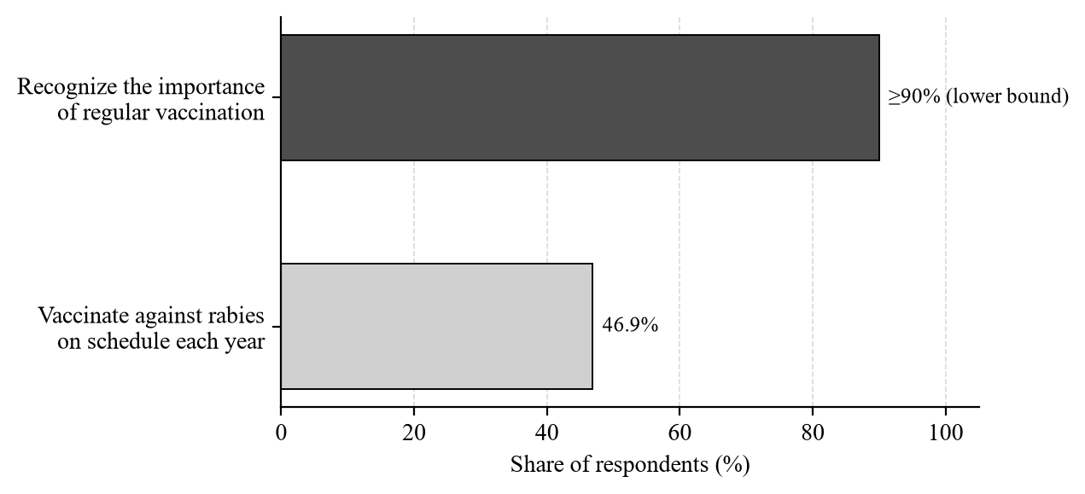
Figure 4-3 The Awareness–Execution Gap in Pet Vaccination
Source: July 2026 survey by the College of Veterinary Medicine, Northwest A&F University. The awareness figure uses the lower bound of “above 90%” and is illustrative only.

4.5 Competitive Analysis

4.5.1 Direct Competitors
Direct competitors are apps focused on pet health records in China and abroad. The table summarizes positioning, public pricing and main weaknesses. Prices are converted at about RMB 7.2 per USD; actual app-store prices may vary.
Table 4-4 Direct Competitor Comparison
Product | Positioning | Public price | Key features | Main weaknesses
smapet | Smart pet manager | Free basic; membership about USD 1.99/month | Check-ins, health dashboard, online consultation, rewards store | Feature-heavy; health data depends on hardware; community and store distract
NexaPet | Pet health records | About USD 4/month | Health records, reminders, sharing with veterinarians | Weak Chinese localization; high price
My Pet | Pet health logging | About USD 4.49/month | Profiles, reminders, records | High price; limited support for Chinese use cases
11pets | All-in-one pet records | From about USD 1.99/month | Multi-pet, complete records, reminders | Export and subscription lock-in; reminders fail; complex UI
Traini | AI pet health and translation | About USD 12.99/month | AI interaction, behavior interpretation, health Q&A | Expensive; entertainment and translation focus rather than core records

4.5.2 Indirect Competitors
Indirect competitors are the alternatives owners use most today. Their strengths and weaknesses are as follows:
Table 4-5 Indirect Competitor Comparison
Alternative | Strengths | Weaknesses
WeChat favorites / chats | Quick to save; zero cost | Hard to search; no due-date reminders; family members keep separate copies
Notes app | Free and simple | No structured fields; no due-date reminders
Paper vaccination booklet | Recognized by clinics; no phone needed | Easy to lose; hard to share; no trend view
Clinic mini-program | Data from the clinic; some records accessible | Single clinic only; no cross-clinic exchange; hard to export a complete record

4.5.3 App Store Review Analysis
The team reviewed public ratings and reviews of similar products on Google Play and the App Store. 11pets has a Google Play rating of about 3.2 (about 5.34 thousand reviews). One- to three-star reviews cluster around four issues: data becomes inaccessible or cannot be exported after subscription changes; reminders fail and cause missed deworming; updates make the interface more complex and navigation worse; and login or sync failures occur. PETKIT users also report crashes when exporting weekly reports and a crowded interface. Public reviews of smapet are mostly positive about check-ins and reward redemption but include disputes over campaign rules.
These reviews point to clear baseline expectations: data must be exportable, reminders must be reliable, the interface must be restrained, and first use must not be blocked by forced registration or a paywall. Those gaps are the project's entry point.

4.6 Market Positioning and Opportunity
The positioning is “a local-first health management tool for Chinese first-time pet owners”: more professional than a notes app, lighter and more private than an all-in-one platform, and more attuned to Chinese pet-care scenarios than overseas products. The product does not try to cover consultations, shopping and community in one place; it goes deep on records, reminders and family coordination.
The opportunity comes from three directions. First, the Chinese market lacks a lightweight tool focused on health records and family sharing. Second, since the Personal Information Protection Law took effect, users are more sensitive to health-data privacy, and local-first can build differentiated trust. Third, pet medical and insurance services are digitizing quickly, and clinics and insurers need low-cost, structured health-data entry points, which creates room for referral partnerships.
This positioning still needs validation through hands-on competitor testing and user research. The current product prioritizes health records, periodic reminders and local storage; family sharing is a later enhancement and will not be rolled out at the same time as the MVP.

4.7 Quantitative and Qualitative Support
Quantitatively, the plan cites the white paper's consumption scale, dog and cat structure, medical share, demographic structure and health-information channels; CNNIC's mobile-internet data; university surveys on immunization execution; and public app-store ratings and review counts. These sources are traceable, and their definitions are listed in the appendix.
Qualitatively, public discussions, the team's observations of pet owners around them and the planned 5–8 first-time-owner interviews all point to three scenarios: the vaccination booklet cannot be found, care handover is unclear during travel, and medical history is hard to explain at a visit. Together they show that users do not need more information; they need a health record that is always available, shareable and portable. The plan does not write interviewee quotes before the interviews are completed.

5. Business Model and Revenue Strategy

5.1 Revenue Model
Revenue is primarily subscription-based, supplemented by insurance referrals and clinic partnerships. Value-added services and product recommendations require a larger user base to convert effectively and cannot be reliably validated within a course project, so they are long-term plans rather than core MVP revenue. Insurance referrals and clinic partnerships have clear industry precedents: in May 2026, the JD Pet ecosystem and New Ruipeng signed a strategic agreement covering internet veterinary hospitals, home testing and pet insurance, connecting bookings, medical-record transfer and direct claims. This validates the “platform referral + provider delivery + commission” path and makes it suitable as a second revenue curve from the MVP stage.
Table 5-1 Revenue Sources and Stage
Revenue source | Payer | Pricing | Stage | In model
Subscription | Users | RMB 12–18/month; RMB 68–98/year | Core revenue from MVP | Yes
Insurance referrals | Insurers | 8%–15% commission on first-year premium | Second curve; pilot from Year 1 | Yes (small)
Clinic partnerships | Veterinary clinics | 5%–10% of visit value or annual fee | Pilot from Year 1 | Yes (small)
Value-added services | Users | RMB 3–9 per use; family-sharing add-on RMB 6/month | Limited pilot; long-term | No
Product recommendations | E-commerce alliances | 3%–15% CPS commission | Long-term plan | No

5.2 Subscription (Core Revenue)
The subscription uses a two-tier structure of free acquisition plus paid value:
Table 5-2 Free and Premium Features
Tier | Scope
Basic (free) | Pet profiles, basic records (weight, vaccines, deworming), one pet
Premium (subscription) | Multi-pet management, data export, AI health reports, family sharing

Pricing references the market: NexaPet is about USD 4/month (about RMB 29), My Pet about USD 4.49/month (about RMB 32) and smapet membership about USD 1.99/month (about RMB 14). Considering Chinese owners' subscription habits and purchasing power, the recommended price is RMB 12–18 per month (RMB 15 used in the model) or RMB 68–98 per year (RMB 80 used, about RMB 6.7 per month). Assuming about 60% monthly and 40% annual subscribers, the weighted average monthly fee is about RMB 12.

5.3 Value-Added Services
Light, on-demand add-ons sit outside the subscription: a one-off AI deep health report (RMB 3–9), a family-sharing add-on (+RMB 6/month) and personalized feeding and care advice packs. These require both a user base and paid habits, so the course project only runs small pilots and excludes them from core revenue projections.

5.4 Pet Insurance Referrals
With pet insurers, users can compare and purchase policies in the app, and the platform earns a commission on a share of the first-year premium (commonly 8%–15%). About 1%–2% of subscribers are expected to convert, a natural referral from the subscriber pool that adds no acquisition cost. China's pet insurance premiums were about RMB 3.0–3.5 billion in 2025, but penetration is only about 1%–3%, leaving substantial room for growth; this makes it a lightweight early-stage revenue pilot.

5.5 Veterinary Clinic Partnerships
The team will pilot with 3–5 community veterinary clinics. Users book vaccinations, checkups and home testing through the app; clinics pay a 5%–10% commission on visit value or an annual partnership fee. In return, the app provides electronic records and booking tools, creating two-way traffic. The model follows the JD–New Ruipeng “internet hospital + home testing” path and has low per-site validation cost.

5.6 Pet Product Recommendations
Through e-commerce alliances such as Taobao Alliance and JD Alliance, the app can recommend pet food, supplements and daily supplies on a CPS basis, with commissions of about 3%–15%. This revenue depends on user scale, usage frequency and trust, so it is a long-term plan to start after the user base reaches a meaningful size.

5.7 Pricing Strategy
Pricing follows three principles. First, benchmark international products: NexaPet and My Pet cost about RMB 29–32 per month, so a domestic price at roughly half that level (RMB 12–18/month) fits target users' willingness to pay. Second, cover costs: variable cost per user (AI API + server amortization) is about RMB 0.5–1 per month, well below the price, leaving ample gross margin. Third, use annual discounts (equivalent to 5.6–6.8 months of the monthly price) to improve retention and cash flow. The free tier acquires users and builds trust; the paid tier converts them with high-value features such as AI health reports, creating a “free funnel + paid conversion” loop.

5.8 Path to Profitability
Short term (MVP to Year 1): subscription revenue covers servers, AI API and marketing, achieving monthly break-even. Medium term (Years 2–3): subscription revenue grows steadily, and insurance referrals and clinic partnerships form a second curve. Long term (after Year 3): once the user base reaches scale, product recommendations and value-added services expand, creating a diversified “subscription + referral + transaction” structure. Core metrics are MRR, paid conversion, LTV/CAC and referral conversion.

5.9 Key Partners
There are four groups: pet insurers (referral and commission sharing); community veterinary clinics (service delivery, commissions and mutual traffic); e-commerce alliances (CPS product recommendations); and cloud and AI API providers (cost side). Pet communities, rescue organizations and campus clubs can also serve as low-cost acquisition channels and are included in early partnerships.

6. Marketing Strategy

6.1 Acquisition Channels
Given the limited budget of a course project, acquisition prioritizes zero- or low-cost channels, ranked as follows:
1. Veterinary clinic and pet-store partnerships. Work with 3–5 community clinics and pet stores in and around Guangzhou, placing QR codes and vaccination-cycle cards; staff recommend the app when owners create a profile or vaccinate. The partnership is traffic exchange first, with no fixed fee in the early stage.
2. Content marketing on Xiaohongshu, Douyin and Bilibili. Publish 1–2 posts or short videos per week on topics such as “the first month with a new cat”, “vaccination and deworming schedules” and “what to prepare before a vet visit”, emphasizing local privacy and family sharing.
3. Pet and campus community operations. Join local Guangzhou pet WeChat groups, campus pet clubs and rescue organizations; offer free vaccination-calendar and health-record templates; run a monthly “vaccine and deworming reminder day” to attract trials.
4. App store optimization (ASO). Optimize the app name, subtitle, screenshots and keywords for long-tail terms such as “pet health”, “vaccine reminder”, “deworming record”, “pet profile” and “cat health”.
5. Referral rewards. When an existing user invites a new user who completes a profile, both receive one month of premium access; family members joining through sharing are a natural form of propagation. Set a monthly cap to prevent abuse.
On compliance, marketing will not claim diagnosis or treatment or replace veterinary care; the team will not manipulate reviews or fabricate testimonials; referral rewards will follow app-store and social-platform rules. All external claims will match actual product capabilities and avoid overpromising for short-term conversion.

6.2 Launch Plan and Rollout
The rollout aligns with the development milestones in Chapter 7 and proceeds in four stages, each with explicit completion criteria; the team will not move to the next stage before meeting them.
Table 6-1 Rollout Stages and Targets
Stage | Timing | Key actions | Completion criteria
Private beta | Months 1–5 | Recruit 20–50 seed users (classmates, friends, clubs); run a WeChat group for feedback; ship weekly builds | Core flow usable; at least 20 users active for 2 consecutive weeks
Campus launch | Months 6–8 | Join campus pet clubs and dorm groups; open a Xiaohongshu account; pilot reminder cards at 2–3 pet stores or clinics | ≥500 activated users; Day-7 retention ≥25%
Content scale-up | Months 9–12 | Publish 1–2 posts per week; optimize ASO; enable referral rewards after family sharing launches | ≥2,000 activated users; year-end MAU about 1,700
Scale validation | Months 13–18 | Expand to 3–5 clinic partners; pilot annual subscriptions and insurance referrals | MAU 2,500; paid conversion ≥5%

The team will not run large-scale paid acquisition during this period, to avoid raising CAC before retention is validated. Year 1 targets about 2,000 cumulative activated users and about 1,700 MAU at year-end, consistent with the Chapter 8 assumption of 1,000 average MAU in Year 1; Year 2 and Year 3 MAU targets are 2,500 and 4,500.

6.2.1 Validation Channels and Criteria
Before launch, the team will not chase downloads. Instead, it will use four low-cost channels to validate whether the core “profile–reminder–export” loop is genuinely used. Each channel has pass criteria; if the data fall short, the team will fix the product first, not move to the next stage or expand spending. Validation results feed into the metrics table in Section 6.5.
Table 6-2 Validation Channels and Pass Criteria
Validation channel | Approach | What it validates | Pass criteria
Seed-user beta | Recruit 20–50 classmates, friends and club members; run a WeChat group; ship a build weekly and collect feedback | Core-flow usability, reminder reliability, willingness to keep using | ≥20 users active for 2 weeks; profile completion ≥80%
Campus clubs and dorm groups | Join campus pet clubs and dorm groups; offer a free vaccination calendar template; invite trials | Whether first-time users can complete a profile and set reminders on their own | Activation ≥60%; Day-7 retention ≥25%
Clinic and pet-store pilot | Place QR codes and reminder cards at 2–3 partner stores; staff guide customers to scan | Scan-to-profile conversion in offline settings | Scan rate ≥5%; profile completion after scan ≥50%
Closed app-store testing | Invite 30–50 users through closed-testing channels on app stores | Install success, crashes and store-page conversion | Crash rate <1%; store rating ≥4.5

All four channels rely on existing campus, community and partner-store resources; no paid acquisition is planned during validation. Test and interview data are used only for product improvement, with consent obtained and results anonymized. Health information about users' pets is handled under the privacy rules in Chapter 7.

6.3 Marketing Budget by Stage
The budget follows the low-cost approach of a student team and matches the “marketing” line in the financial forecast: RMB 1,000 in Year 1, RMB 2,000 in Year 2 and RMB 3,000 in Year 3. The Year 1 budget is allocated as RMB 0 for the private beta, RMB 200 for the campus launch, RMB 500 for content scale-up and RMB 300 for the commercialization pilot; allocations are adjusted based on results, and annual cash spending will not exceed the budget.
Table 6-3 Annual Marketing Budget (RMB)
Item | Year 1 | Year 2 | Year 3 | Notes
Content production and samples | 300 | 700 | 1,000 | Posts, short videos, vaccination calendar templates
Campus and community events | 250 | 500 | 800 | Club partnerships, offline talks
Clinic and store materials | 200 | 350 | 500 | QR reminder cards, posters
App store and small paid tests | 150 | 300 | 450 | Keyword tests, small-scale tests
Other | 100 | 150 | 250 | Event gifts, shipping, miscellaneous
Total | 1,000 | 2,000 | 3,000 | —

6.4 User Retention Strategy
Retention is designed from first use. After a new user creates a pet profile, the app guides them within seven days to set a first vaccine or deworming reminder, and gives clear completion feedback when the first reminder fires, so the user experiences the value of “being reminded” quickly.
Daily retention relies on six mechanisms. First, reminders drive return visits: vaccine, deworming and checkup due dates are natural reasons to open the app. Second, recording is kept to three steps for common entries such as weight, medication and visits, with a “copy last record” option. Third, accumulated data creates switching cost, while one-click export removes the fear of lock-in. Fourth, family sharing lets multiple members confirm reminders together, reducing single-user churn. Fifth, light content brings users back: a monthly “pet health checklist” and at most one weekly notification, which can be turned off at any time. Sixth, a community feedback loop: replies in the WeChat group within 24 hours, and accepted suggestions are listed in the changelog with public credit.
For churned users, the team uses in-app surveys and WeChat follow-ups to distinguish “not needed”, “don't know how to use it”, “inaccurate reminders” and “price”, and responds with onboarding, template improvements and coupons respectively, rather than frequent push notifications.

6.5 Marketing Metrics
Marketing is measured by verifiable behavioral metrics, not downloads alone. Because the app supports use without registration, an “activated user” is defined as a user who completes at least one pet profile. The following figures are team targets, not achieved results, and will be calibrated after the beta.
Table 6-4 Marketing Metrics
Metric | Definition | Year 1 target
CAC | Marketing spend ÷ new registered users | ≤ RMB 15
Activation rate | New users who complete a pet profile and set at least one reminder | ≥60%
Reminder setup rate | Users with at least one reminder ÷ activated users | ≥50%
Day-7 retention | Users who open the app on Day 7 after registration | ≥25%
Day-30 retention | Users who open the app on Day 30 after registration | ≥12%
MAU | Opened the app at least once in the month | Average 1,000; about 1,700 at year-end
QR scan rate | Scans ÷ cards distributed | ≥5%
Family-sharing adoption | Users who invite at least one family member (after launch) | ≥15%
Paid conversion | Paying users ÷ MAU | 5%
Annual-plan share | Annual subscribers ÷ all paying users | About 40%
Referral coefficient K | New users per existing user | ≥0.3
Content-sourced registrations | Registrations from content ÷ total registrations | ≥30%

7. Development and Operations Plan

7.1 Development Plan and Milestones
Development follows the sequence “validate the core value first, then add collaboration and AI”, avoiding overinvestment in features before demand is validated.
Table 7-1 Development Milestones
Stage | Timing | Main tasks
Requirements and design | Months 1–2 | Requirement freeze, information architecture, low-fidelity prototype, technology selection, privacy design
MVP development | Months 3–4 | Pet profiles, health records and smart reminders
Beta and fixes | Month 5 | Beta with 50 seed users, crash fixes, usability testing
Public launch | Month 6 | App-store listing, privacy policy and filings, rating prompts
Iteration 1 | Months 7–9 | Family-sharing beta, data export, ASO optimization
Iteration 2 | Months 10–12 | Subscription launch, AI health assistant beta, annual review
Year 2 | Months 13–24 | iOS evaluation, clinic partnership tools, retention optimization
Year 3 | Months 25–36 | Multi-pet management, deeper insurance referrals, product-recommendation pilot

Two implementation caveats apply. First, WorkManager is designed for deferrable work and cannot guarantee on-time reminders on every device; the team must test system alarms, background limits, device restarts and battery optimization on target devices, and provide setup guidance where necessary. Second, the boundary between local-first and family sharing must be defined before development: the MVP stores data locally by default with sync off; family sharing syncs only necessary data after the user explicitly enables it, and must address authentication, authorization, transport encryption, data conflicts and revocation. The technical lead will confirm feasibility before implementation.

7.2 Development Costs
Labor is self-funded by the team and excluded from cash spending. During MVP development, the team uses Firebase free tiers, Gemini free quota and Figma's free plan, keeping monthly cash cost at RMB 0–100. After launch, as users and AI usage grow, annual server, AI API and tool costs are about RMB 3,500, or about RMB 292 per month.
Table 7-2 Development and Operating Costs
Item | MVP development (per month) | Year 1 of operations (per year)
Labor | Team-funded, RMB 0 | Team-funded, RMB 0
Servers and cloud | RMB 0–50 (free tier) | RMB 1,200
AI API calls | RMB 0–30 (free quota) | RMB 1,500
Testing and design tools | RMB 0 (Test Lab, Figma free tier) | RMB 800 (domain, tools, materials)
Total | RMB 0–100 | RMB 3,500

Note: Year-1 operating costs exclude marketing. The RMB 1,000 marketing budget is shown in Table 6-3 and Table 8-2.
These cost assumptions must be verified before implementation: free tiers, terms and network availability for Firebase, Gemini and similar services depend on official information and actual testing. If they are unavailable in the target environment, the team will evaluate domestic alternatives or implement simplified data sharing through file import and export. During the course stage, distribution will prioritize controlled APK beta testing; before listing on domestic app stores, the team must verify entity qualifications, app filing and platform requirements. Related fees are not yet included in the budget.

7.3 Operations Plan
For content operations, the team publishes 1–2 pet-care posts per week focused on vaccination cycles, deworming plans, weight management and visit preparation, avoiding entertainment content. The same content is distributed to Xiaohongshu, Douyin, Bilibili and an H5 landing page, creating a lightweight “produce once, distribute across channels” matrix.
For user support, the team runs a WeChat user group and a feedback form, with members taking shifts and committing to respond within 24 hours. Feedback is categorized as bug, experience, feature request or complaint, reviewed weekly, and accepted suggestions are recorded in the changelog; issues affecting the core flow are fixed first.
For privacy and compliance, the team follows the Personal Information Protection Law and the Cybersecurity Law under the principle of minimum necessity: pet health data is stored locally by default and cloud sync requires explicit opt-in; phone numbers are collected only for accounts and recovery, with no access to contacts, precise location or advertising identifiers; users can export and delete all data at any time. Before launch, the team will complete a privacy policy, permission disclosures and app filing. In the event of a data-security incident, the response plan will be activated within 24 hours for investigation and notification.
There are precedents of pet apps being cited for personal-information issues. In October 2025, the National Computer Virus Emergency Response Center reported 70 mobile apps for illegal collection and use of personal information. Among them, “Pet Home” was cited for lacking effective correction, deletion and account cancellation functions, and “TA Island Pet” for an inadequate complaint-handling mechanism. The project treats account cancellation, data deletion and complaint response as mandatory pre-launch checks.
From a compliance perspective, pet health records are not automatically personal information; when linked to a phone number, account, location or family member and thus able to identify a natural person, they must be handled under the Personal Information Protection Law. The team's pre-launch checklist is:
1. Show a privacy notice on first run with access to the full policy; do not pre-check consent.
2. List each type of information collected, its purpose, retention period and third-party SDKs; separate notice and consent are required before providing data to third parties.
3. Do not force registration or request permissions unrelated to features; request permissions only when they are used.
4. Provide entry points for data export, correction, deletion and account cancellation, and respond promptly.
5. Store data locally by default; cloud sync is opt-in and encrypted in transit.
6. Do not use pet health data for advertising; assess AI compliance separately before launch.

7.4 Lifecycle Goals
The project lifecycle has three phases. Months 0–6 are the MVP validation phase, testing whether the “profile–reminder–visit export” loop is actually used. Months 6–24 are the growth phase, targeting 2,500 MAU and a working subscription model. After Month 24 is the commercialization phase, building diversified revenue from insurance referrals, clinic partnerships and value-added services. Each phase has exit criteria tied to the metrics in Section 6.5; if key metrics fall short, the team will analyze the cause and continue iterating rather than pushing commercialization on a fixed timetable.

7.5 Team Roles and Collaboration
The team uses a three-person parallel structure coordinated by the team leader. Lu Siyu leads product direction, technical implementation and overall schedule, with final decision authority on product requirements; He Yuxin leads market analysis, user research, content and community operations; Huang Lidian leads the business model, pricing, financial modeling and compliance records.
The team holds a weekly meeting and syncs asynchronously daily, working in two-week iterations. Requirements, defects and tasks are tracked on a shared board; code is managed with Git and reviewed by at least one other member; documents and financial records are stored in a shared cloud drive. At the end of each stage, the team reviews performance against the Section 6.5 metrics; SOM, conversion and budget figures stay consistent with Chapter 8 and are changed only after all three members agree. Budget, pricing and partnership decisions are discussed by all three; if views differ, the team leader decides after hearing everyone and the decision is reviewed at the next meeting.

8. Financial Projections

8.1 Key Assumptions
The forecast uses a calendar year, RMB and no exchange-rate fluctuations. There is no external financing; the project is funded by the team with about RMB 10,000 in startup capital. Key assumptions are:
(1) MAU: about 1,000 on average in Year 1 (from about 300 at the start to about 1,700 at year-end), about 2,500 in Year 2 and about 4,500 in Year 3, driven mainly by campus and pet-community word of mouth.
(2) Paid conversion: 5% in Year 1, 8% in Year 2 and 10% in Year 3, at the low-to-middle end of the 5%–15% range typical for Chinese subscription products.
(3) CAC: about RMB 10–20, with RMB 15 used in the model. Early acquisition relies mainly on communities and word of mouth, with small paid tests as a supplement.
(4) LTV: based on the UPET case (LTV USD 74.7 over three years, CAC USD 19.3, LTV/CAC 3.4:1). Adjusted for domestic subscription prices and purchasing power: average monthly fee RMB 12, average subscription period 7–10 months, LTV about RMB 80–120, CAC about RMB 10–20, LTV/CAC about 4–8:1, above the industry health line of 3:1.

8.2 Revenue Projections
Monthly recurring revenue (MRR) = subscribers × average monthly fee (RMB 12); annual recurring revenue (ARR) = MRR × 12 + referral revenue from insurance and clinic partnerships.
Table 8-1 Revenue Projections (RMB)
Item | Year 1 | Year 2 | Year 3
Average MAU | 1,000 | 2,500 | 4,500
Paid conversion rate | 5% | 8% | 10%
Average paying subscribers | 50 | 200 | 450
Average monthly subscription fee | 12 | 12 | 12
MRR (subscribers × monthly fee) | 600 | 2,400 | 5,400
Subscription revenue (MRR × 12) | 7,200 | 28,800 | 64,800
Referral revenue (insurance/clinics) | 1,800 | 6,000 | 12,000
ARR (MRR × 12 + referral revenue) | 9,000 | 34,800 | 76,800

8.3 Projected Income Statement
The course project uses a simplified three-year statement showing revenue, costs (servers, AI API, marketing) and net profit:
Table 8-2 Projected Income Statement (RMB)
Item | Year 1 | Year 2 | Year 3
Revenue | 9,000 | 34,800 | 76,800
Cost: servers and cloud | 1,200 | 2,400 | 3,600
Cost: AI API calls | 1,500 | 5,000 | 11,000
Cost: marketing | 1,000 | 2,000 | 3,000
Cost: other (domain, tools, materials) | 800 | 1,200 | 1,500
Total cost | 4,500 | 10,600 | 19,100
Net profit | 4,500 | 24,200 | 57,700
Net margin | 50% | 70% | 75%

Note: Costs exclude team labor. At market salaries, the net margin would be materially lower.

8.4 Break-Even Analysis
Year 1 average monthly total cost is about RMB 375 (4,500 ÷ 12). At RMB 12 per subscriber, about 32 subscribers cover monthly costs (375 ÷ 12 ≈ 32). Paying users grow from about 10 at the start of Year 1 to about 90 at year-end (average about 50), so monthly break-even is expected around Month 7; profitability improves markedly from Year 2.
If paid conversion is lower than assumed—for example, only 3% in Year 1—average paying users would be about 30, subscription revenue about RMB 4,320, and with referral revenue the project could still cover variable costs, but net profit would narrow significantly. The team therefore prioritizes free-tier experience and reminder reliability before growth, securing retention before pushing conversion.

8.5 Cash Flow Projections
With no external financing, cash flow depends on about RMB 10,000 of team capital. Months 1–6 cover product development and early launch, with monthly net outflow of about RMB 200–400. As subscriptions grow, monthly cash flow turns positive around Month 7. Cash at year-end is about RMB 14,500 in Year 1, RMB 38,700 in Year 2 and RMB 96,400 in Year 3, with no borrowing pressure and a sound financial structure.

8.6 Three-Year Financial Summary
Table 8-3 Three-Year Financial Summary (RMB)
Metric | Year 1 | Year 2 | Year 3
Average MAU | 1,000 | 2,500 | 4,500
Average paying subscribers | 50 | 200 | 450
Paid conversion rate | 5% | 8% | 10%
MRR | 600 | 2,400 | 5,400
ARR | 9,000 | 34,800 | 76,800
Net profit | 4,500 | 24,200 | 57,700
Cash at year-end | 14,500 | 38,700 | 96,400

Note: Projections use conservative assumptions consistent with a small student project (first-year revenue in the thousands to tens of thousands of RMB, self-funded capital of RMB 10,000–20,000) and do not assume aggressive growth. Cash at year-end is simplified as opening self-funded capital plus cumulative net profit, excluding working-capital needs.
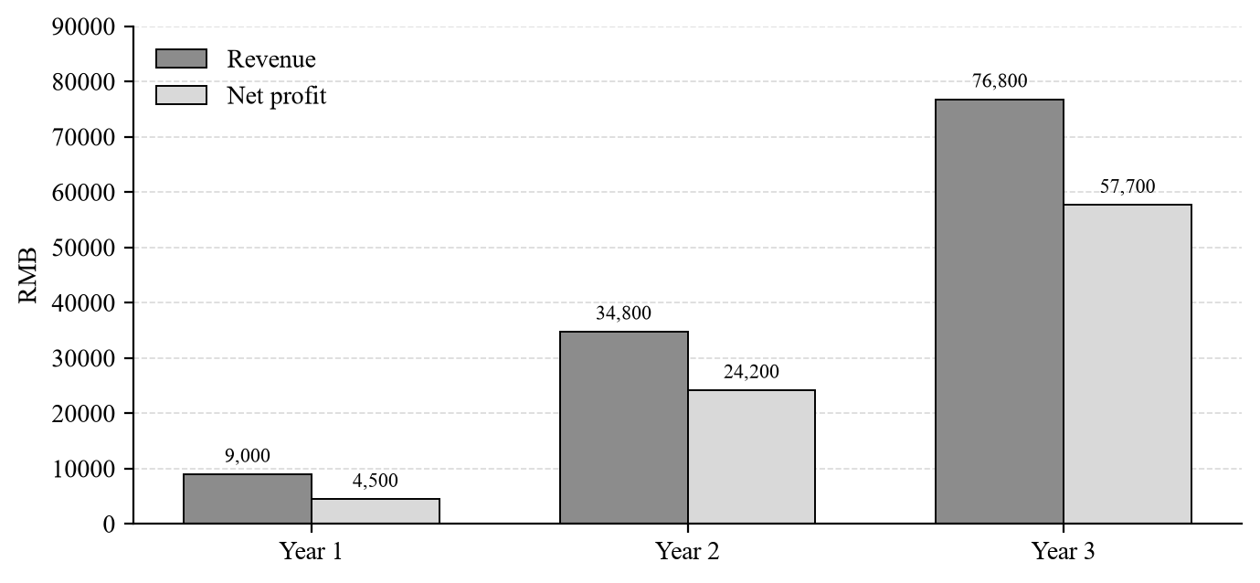
Figure 8-1 Three-Year Revenue and Net Profit Forecast

9. Team

9.1 Members and Responsibilities
The team has three members in a “three parallel tracks, leader-coordinated” structure. The product and technology lead also serves as team leader, responsible for overall direction and schedule; the marketing and user lead and the business and finance lead each own their respective areas:
Table 9-1 Team Responsibilities
Member | Role | Responsibilities | Chapters
Lu Siyu | Product & Technology Lead (Team Leader) | Product description, technical architecture, risk analysis, overall schedule | 1, 2, 3, 10
He Yuxin | Marketing & User Lead | Market analysis, user research, marketing strategy, community operations | 4, 6, 7
Huang Lidian | Business & Finance Lead | Business model and revenue strategy, financial projections, team and compliance | 5, 8, 9

9.2 Background and Capabilities
(1) Lu Siyu (Product & Technology Lead, Team Leader): has a foundation in Kotlin and Android development and is familiar with Jetpack Compose, Room, Hilt and WorkManager. Can independently build pet profiles, health records and reminder modules and integrate the Gemini API; has product prototyping and UI/UX skills and can complete information architecture and interaction design. As team leader, responsible for requirement breakdown, task allocation and overall schedule.
(2) He Yuxin (Marketing & User Lead): has market research and user-research experience and is familiar with content operations on Xiaohongshu, Douyin and Bilibili as well as campus and community groups. Can complete competitive analysis, user interviews and campaign execution. Responsible for free acquisition, word-of-mouth, clinic partnerships and insurance referral plans.
(3) Huang Lidian (Business & Finance Lead): has a foundation in financial modeling and business analysis and can complete cost accounting, revenue models, income statements and cash-flow forecasts. Familiar with subscription and referral-commission models and has researched pet insurance and veterinary partnership cases. Responsible for the business model, financial projections and team sections of this plan.

9.3 Advisors and Non-Technical Staff
There are currently no external advisors. Product, technology, marketing and finance functions are handled directly by the team, with no non-technical advisory roles. If veterinary content review is needed later, the team plans to invite 1–2 licensed veterinarians as part-time advisors and pay per consultation.

9.4 Organizational Chart
The team uses a simple tree structure: the product and technology lead also serves as team leader and coordinates the whole project; the marketing and user lead and the business and finance lead work in parallel and report to the leader.
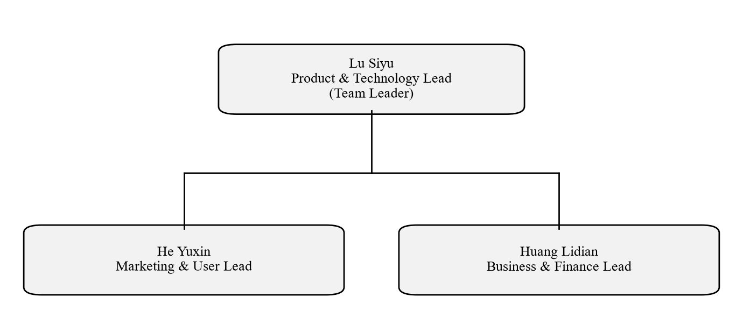
Figure 9-1 Team Organization

9.5 Equity and Stakeholders
No actual equity is allocated during the course project. If a company is registered later, the three members will negotiate equity in proportion to contribution; the team leader makes final decisions on product direction and major spending, while equity changes, financing and external partnerships require unanimous consent.
Current stakeholders include users, partner veterinary clinics, insurers, and cloud and AI API providers. There are no external investors and no performance guarantees, repurchase or guarantee clauses. User data is not a realizable asset and is not part of any transaction.

10. Risk Analysis and Mitigation

10.1 Market Competition Risk
The pet health track already includes smapet, NexaPet, 11pets and other products, and all-in-one platforms are extending into health records. If leading products quickly add family sharing and local privacy, the project's differentiation will narrow.
Mitigation: focus on the niche of Chinese first-time cat owners rather than full-category coverage; make local-first and family sharing tangible product experiences rather than slogans; maintain a fast, lightweight iteration pace and prioritize reminder reliability and data export, building a reputation-based moat.

10.2 Technical Implementation Risk
AI health analysis has limited accuracy and may give inappropriate advice; Gemini API free quotas, pricing and terms may also change.
Mitigation: label all AI output as reference only and not a substitute for veterinary diagnosis, and never provide prescriptions or dosages; use conservative response templates for high-risk symptoms and direct users to seek care promptly; retain rule-based local reminders and a common-questions library so core features work when the API is unavailable; cap per-user usage with a monthly quota.

10.3 User Acquisition Risk
The course project has a limited budget and cannot run large-scale promotion; pet health management is a low-frequency scenario, and users may not open the app for long periods after creating a profile.
Mitigation: start with campuses and nearby pet owners and focus on deep user operations rather than downloads; create usage frequency through reminders, weight tracking and family sharing; partner with clinics and pet stores for precise acquisition; set stage targets and do not expand spending before retention targets are met.

10.4 Data Privacy and Compliance Risk
Pet health data is related to personal information. Excessive permissions, an unclear privacy policy or a difficult account-cancellation process could violate the Personal Information Protection Law and trigger a trust crisis. Pet apps were cited for personal-information issues in 2025.
Mitigation: store data locally by default and require explicit opt-in for cloud sync; minimize permissions and avoid contacts, precise location and advertising identifiers; provide a clear privacy policy and data-export and account-cancellation entry points; complete app filing and a compliance self-check before launch, with Huang Lidian designated as data protection lead; in a security incident, notify users and regulators promptly under the response plan.

10.5 Financial Risk
Revenue may not cover costs, especially as AI API usage and marketing spending rise with users; if paid conversion falls below 5%, cash flow will come under pressure earlier than projected.
Mitigation: prioritize free-tier services and keep fixed costs below RMB 300 per month; approve marketing spend monthly and pause paid acquisition when CAC exceeds RMB 30; keep RMB 10,000 of self-funded capital as a buffer and set a monthly cash-flow warning line; validate subscription conversion before launching insurance and clinic partnerships.

10.6 Risk Mitigation Summary
Table 10-1 Risk and Mitigation Summary
Risk | Likelihood | Impact | Main mitigation | Owner
Market competition | Medium | Medium | Focus on the niche; strengthen local privacy and family sharing; iterate quickly on core experience | Lu Siyu
Technical delivery | Medium | Medium | AI disclaimers; conservative response templates; keep rule-based fallback; cap usage | Lu Siyu
User acquisition | High | Medium | Deep campus and community operations; clinic partnerships; no paid scale-up before retention targets are met | He Yuxin
Privacy and compliance | Medium | High | Local-first; minimal permissions; export and account deletion; filings and compliance self-check | Huang Lidian
Financial | Medium | Medium | Use free tiers; CAC alerts; monthly cash-flow review | Huang Lidian

11. Appendix

11.1 Data Sources
The main data sources cited in this plan are:
1. Paidu Pet Industry Big Data Platform. 2026 China Pet Industry White Paper (Consumer Report). January 2026; data for 2025.
2. CCTV.com. “2026 China Pet Industry White Paper officially released: market surpasses RMB 310 billion.” January 5, 2026.
3. Guangming Online. Same report. January 5, 2026.
4. Xinhua Finance. “The RMB 300 billion pet market continues to expand; full-chain pet finance opens new growth.” June 7, 2026.
5. China Internet Network Information Center (CNNIC). 57th Statistical Report on China's Internet Development. December 2025 data; mobile internet penetration 99.6%.
6. Northwest A&F University, College of Veterinary Medicine social practice team. Pet immunization “knowing–doing gap” survey. July 2026; cited by Toutiao and Baidu News.
7. Sichuan Agricultural University, College of Veterinary Medicine “Pet Decode” survey team. Summer 2025 pet-care awareness survey, 100 valid responses. August 2025.
8. National Computer Virus Emergency Response Center. Notice on 70 mobile apps illegally collecting and using personal information. October 30, 2025.
9. New Ruipeng Pet Healthcare Group. JD Pet Ecosystem and New Ruipeng sign strategic cooperation agreement. May 28, 2026.
10. Public pages and user reviews on Google Play and Apple App Store; accessed October 2026.
11. UPET public case data (LTV USD 74.7, CAC USD 19.3, LTV/CAC 3.4:1), compiled by the team.

11.2 References
Main references and URLs (accessed October 2026):
1. 2026 China Pet Industry White Paper release report: https://business.cctv.cn/2026/01/05/ARTIdmv2AWmVeRVodaZYLOvQ260105.shtml
2. Guangming Online reprint: https://m.gmw.cn/toutiao/2026-01/05/content_1304291767.htm
3. Xinhua Finance pet finance market analysis: https://www.cnfin.com/cjfx-lb/detail/20260607/4423070_1.html
4. National Computer Virus Emergency Response Center notice: http://www.cverc.org.cn/zxdt/report20251030.htm
5. New Ruipeng and JD cooperation announcement: https://ruipengpet.com/news/detail/259
6. Sichuan Agricultural University survey report: https://dyy.sicau.edu.cn/info/1040/17612.htm
7. Northwest A&F University survey report: https://m.toutiao.com/article/7673038078948246062/
8. 11pets Google Play page: https://play.google.com/store/apps/details?id=com.m11pets.elevenpets
9. smapet App Store page: https://apps.apple.com/cn/app/id1633569833
10. CNNIC 57th report reprint: https://data.eastmoney.com/report/zw_industry.jshtml?encodeUrl=G5q0J7vI7MapkjMb9ILLSeZcRF0/Bo7lo9zOKI84dtk=
Note: Some industry data are second-hand citations from public reports, and definitions may differ across sources. This plan prioritizes the white paper's definitions and flags limitations in the text. User-research results are not fabricated; the questionnaire and interview plan is in Section 4.4. Financial projections are course-project estimates and do not constitute investment advice.

